Module 2 – Introduction to Programming

**1.Overview of C Programming**

**THEORY EXERCISE**:

Write an essay covering the history and evolution of C programming. Explain its importance and why it is still used today.

C programming, one of the most influential and enduring languages in computing, has a rich history that spans several decades. Its origins trace back to the early 1970s, and its evolution has had a profound impact on the development of software engineering and modern computing.

BIRTH OF C:

The C programming language was developed by Dennis Ritchie at Bell Labs between 1969 and 1972. It was an evolution of an earlier language called B, which itself was a simplified version of the BCPL (Basic Combined Programming Language) used for system programming. The B language, created by Ken Thompson, was used for the development of early UNIX systems. However, as computing needs became more complex, B was deemed inadequate for the expanding scope of system software and application development.

THE EVOLUTION OF C:

As C grew in popularity, it began to evolve. In 1978, Brian Kernighan and Dennis Ritchie published the influential book The C Programming Language, often referred to as the "K&R C" (after the authors' initials). This book not only introduced C to a wider audience but also helped establish its standard syntax and features.

In the early 1980s, the American National Standards Institute (ANSI) formed a committee to standardize C, which resulted in the ANSI C standard in 1989. This version, sometimes referred to as "ANSI C" or "C89," introduced several improvements and clarifications, including enhanced function prototypes, improved type definitions, and support for more structured programming practices. The creation of the ANSI C standard helped make the language more consistent and reliable across different platforms, further cementing its widespread adoption.

The next major revision came in 1999 with the introduction of the C99 standard. This update added several new features, such as inline functions, variable-length arrays, improved support for floating-point arithmetic, and new library functions. While these additions made C more powerful and flexible, they also increased its complexity slightly.

IMPORTANCE OF C:

Despite being over 50 years old, C remains one of the most important and widely used programming languages in the world. There are several reasons for its continued relevance and importance.

C language continues to be used today for several important reasons:

Efficiency and Performance

Portability

System Programming

Foundation of Other Languages

Large Legacy Codebase

Standard Libraries and Tools

Simple and Flexible Syntax

Wide Use in Education

C is still widely used today due to its efficiency, performance, portability, and versatility, especially in system programming, embedded systems, and applications where resource constraints are critical.

**LAB EXERCISE**:

Research and provide three real-world applications where C programming is extensively used, such as in embedded systems, operating systems, or game development.

There are three real-world applications where C programming is extensively used:

**1. Embedded Systems**

**Application**: **Microcontrollers and IoT Devices**

**Why C is used**: Embedded systems often require efficient, low-level programming to manage resources such as memory and processing power. C is ideal for these environments because it provides direct access to hardware and allows developers to write code that runs quickly and uses minimal resources. C is commonly used in microcontrollers, sensors, robotics, and Internet of Things (IoT) devices. For example, C is often the language of choice for firmware in embedded systems like Arduino, Raspberry Pi, and automotive control units.

**2. Operating Systems**

**Application**: **Linux Operating System**

**Why C is used**: C is the backbone of many operating systems, most notably **Linux**, which is written almost entirely in C. Operating systems require direct interaction with hardware and precise memory management, and C provides these capabilities. It allows the OS to run efficiently with control over hardware and system resources, making C crucial for performance-critical parts of operating systems. Additionally, other operating systems like Unix and Windows have also been heavily influenced by C or were initially written in it.

**3. Game Development**

**Application**: **Game Engines (e.g., Unreal Engine, Unity)**

**Why C is used**: C and C++ (which is an extension of C) are widely used in game development because of their ability to handle real-time graphics and complex computations efficiently. Game engines like **Unreal Engine** and game consoles like PlayStation use C for performance-sensitive tasks such as graphics rendering, physics simulations, and input/output operations. Games with high-performance graphics, such as first-person shooters or real-time strategy games, rely on the performance and speed of C to provide smooth gameplay and responsive controls.

**2. Setting up Environment**

**THEORY EXERCISE**:

Describe the steps to install a C compiler (e.g., GCC) and set up an Integrated Development Environment (IDE) like DevC++, VS Code, or Code Blocks.

To start programming in C, you need to install a C compiler (like GCC) and set up an Integrated Development Environment (IDE) such as DevC++, VS Code, or Code Blocks. Below are the **theoretical steps** for setting up these tools.

### ****Step 1: Install a C Compiler (e.g., GCC)****

A **C compiler** is required to translate C code into machine-readable instructions. GCC (GNU Compiler Collection) is the most commonly used compiler for C.

#### **For Windows**

To install GCC on Windows, a popular method is to use **MinGW** (Minimalist GNU for Windows), which provides the GCC compiler and related tools.

* **Download MinGW**: You can download the MinGW installer from the official site.
* **Install MinGW**: During installation, you will select the mingw32-gcc-g++ package, which installs the GCC C and C++ compilers.
* **Update PATH**: After installation, you need to add the MinGW bin directory (where the compiler resides) to the system's **PATH** environment variable. This allows you to run the compiler from the command line or IDE.
* **Verify Installation**: To verify that GCC is correctly installed, you would typically open a terminal or command prompt and run gcc --version, which should display the version of GCC.

#### **For macOS**

On macOS, you can use **Homebrew**, a package manager for macOS, to install GCC.

* **Install Homebrew**: Homebrew can be installed by running a simple script in the terminal.
* **Install GCC**: After Homebrew is set up, you can install GCC by running brew install gcc in the terminal.
* **Verify Installation**: The command gcc --version will confirm that the GCC compiler has been installed.

#### **For Linux (Ubuntu)**

On Linux systems like Ubuntu, GCC is typically available from the system’s package manager.

* **Install GCC**: You can use the package manager apt to install GCC. The command is sudo apt install build-essential, which installs GCC along with other necessary tools for compiling C programs.
* **Verify Installation**: Running gcc --version in the terminal confirms the installation.

### ****Step 2: Set Up an IDE (Integrated Development Environment)****

An IDE simplifies writing, compiling, and debugging programs by providing features like syntax highlighting, code suggestions, and an integrated compiler. Below are some popular IDEs and how to set them up:

#### **Code Blocks**

Code Blocks is a free, open-source IDE widely used for C and C++ development. It integrates with GCC or other compilers.

* **Download and Install**: You download Code Blocks from its official website. There is a version that comes bundled with MinGW, which eliminates the need to separately install the compiler.
* **Configuration**: During installation, the IDE automatically detects the installed GCC compiler, so no additional configuration is necessary.
* **Using Code Blocks**: Once installed, you can create a new C project and write your program. The IDE provides buttons to **build** and **run** the program directly.

#### **DevC ++**

DevC++ is another free, open-source IDE for C/C++ development, commonly used on Windows.

* **Download and Install**: You can download DevC++ from the Source Forge website. It includes the MinGW compiler, so there’s no need to install GCC separately.
* **Using DevC++**: Once installed, you can create a new project, write your code, and use the built-in **compile** and **run** buttons to test your program.

#### **Visual Studio Code (VS Code)**

VS Code is a lightweight, extensible code editor with support for many languages, including C.

* **Download and Install**: You download VS Code from its official website and install it.
* **Install C/C++ Extension**: Once installed, you need to install the C/C++ extension from the VS Code marketplace. This extension adds features such as code completion and debugging support for C.
* **Install GCC**: You also need to install GCC separately (as explained in **Step 1**).
* **Configure VS Code**: After installing the compiler, you need to configure VS Code to use GCC for compiling C programs. This involves setting up tasks like tasks. Son for running the compiler from within the IDE.
* **Using VS Code**: After configuration, you can create a new .c file, write your code, and build/run it using the **Terminal** in VS Code or the custom build tasks you set up.

### ****Step 3: Write and Run Your First C Program****

Once the C compiler and IDE are installed, you can write and execute your first program.

1. **Create a New File/Project**: In the IDE, create a new project or file (usually with the .c extension for C programs).
2. **Write the Code**: Write the following simple C program that prints "Hello, World!" to the console:

#include <stdio.h>

int main() {

printf("Hello, World!\n");

return 0;

}

1. **Compile and Run**:
   * In **Code Blocks** or **DevC++**, you can click **Build and Run** to compile and execute the program.
   * In **VS Code**, after creating the necessary configuration, you can run the program from the terminal or use the configured tasks.
2. **See the Output**: After compiling and running the program, the IDE should display the output:

Hello, World!

**3. Basic Structure of a C Program**

**THEORY EXERCISE**:

Explain the basic structure of a C program, including headers, main function, comments, data types, and variables. Provide examples.

A C program consists of several key components that work together to define its behaviour. The basic structure includes:

**Headers** for including libraries.

The **main function** where the execution begins.

**Comments** to explain the code.

**Data types** that define the kind of data a variable can hold.

**Variables** to store data.

### 1. ****Headers****

Headers are files that contain declarations for functions and variables. These headers typically belong to standard libraries and are included at the top of your program with the #include directive. This allows you to use pre-defined functions and constants in your program. Common headers include stdio.h for input/output operations and stdlib.h for utility functions.

#### Example:

#include <stdio.h> // Header for standard input/output functions

In this example, the stdio.h header is included, which allows the use of functions like printf() for output and scanf() for input.

### 2. ****Main Function****

The main() function is the entry point for every C program. When you run a C program, the execution begins from the main function. Every C program must have a main() function. It typically returns an integer value (int), with 0 indicating successful execution.

#### Example:

int main() {

// program logic goes here

return 0; // Return 0 to indicate successful execution

}

The main function here returns 0, which is a common way to signal that the program has run successfully. The code within the {} braces defines the body of the main() function.

### 3. ****Comments****

Comments are used to explain the code, making it more readable for others and yourself. They are ignored by the compiler and do not affect the program’s execution. There are two types of comments in C:

**Single-line comments**: Start with // and extend to the end of the line.

**Multi-line comments**: Enclosed between /* and */.

#### Example:

// This is a single-line comment /* This is a multi-line comment. It can span multiple lines. */

### 4. ****Data Types****

Data types in C define what kind of data a variable can store. They tell the compiler how much memory is required for storing a value and how to interpret it. Common data types include:

**int**: Used for integers (whole numbers).

**float**: Used for floating-point numbers (decimal values).

**double**: Used for double-precision floating-point numbers.

**char**: Used for single characters.

#### Example:

int age; // Variable for storing integer values

float price; // Variable for storing decimal values

char grade; // Variable for storing a single character

### 5. ****Variables****

Variables are used to store data that can be changed during the execution of the program. Each variable must be declared with a specific data type before it is used. You can assign a value to the variable either at the time of declaration or later in the program.

#### Example:

int age = 25; // Declare an integer variable and assign a value

float price = 19.99; // Declare a float variable and assign a value

char grade = 'A'; // Declare a character variable and assign a value

**4. Operators in C**

**THEORY EXERCISE**:

Write notes explaining each type of operator in C: arithmetic, relational, logical, assignment, increment/decrement, bitwise, and conditional operators.

### ****Arithmetic Operators****:

Arithmetic operators are used to perform basic mathematical operations like addition, subtraction, multiplication, etc.

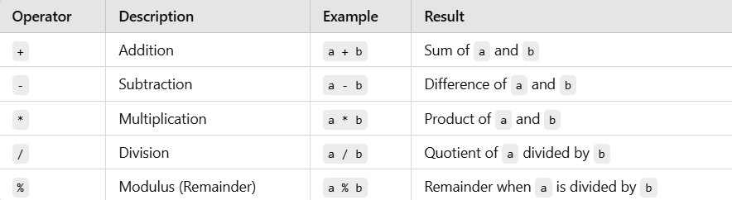

### ****Relational Operators****:

Relational operators are used to compare two values. They return either true (1) or false (0).

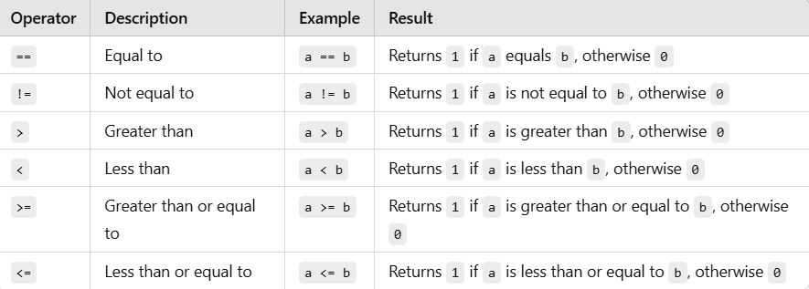

### ****Logical Operators****:

Logical operators are used to perform logical operations, mainly in conditional statements, to combine multiple conditions.

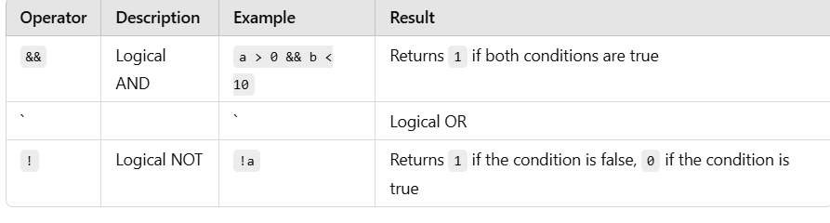

### ****Assignment Operators****:

Assignment operators are used to assign values to variables. The most basic assignment operator is =, but there are also shorthand assignment operators.

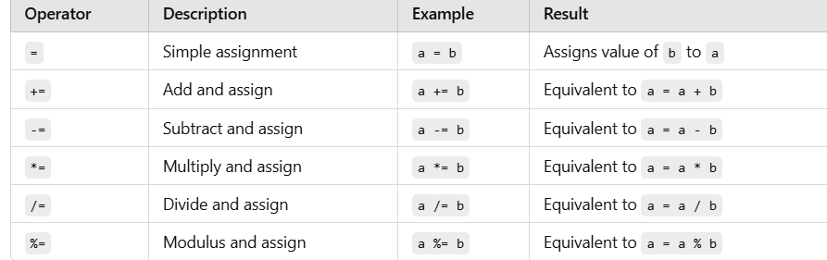

### ****Increment and Decrement Operators****:

The increment (++) and decrement (--) operators are used to increase or decrease the value of a variable by 1, respectively.

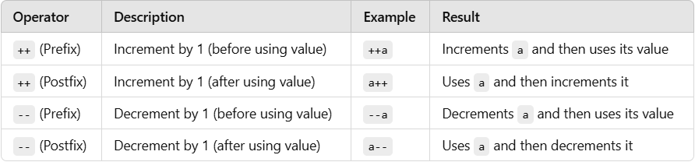

### ****Bitwise Operators****:

Bitwise operators are used to perform operations on bits (binary representations of numbers). These operators operate directly on the binary form of integers.

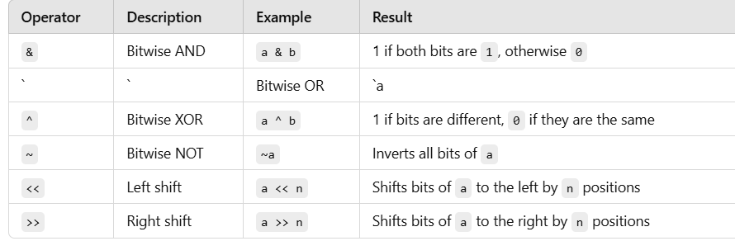

### ****Conditional Operator****:

The conditional operator is a shorthand way of writing an if-else statement. It takes three operands and is used to evaluate a condition, returning one of two values based on the result of the condition.

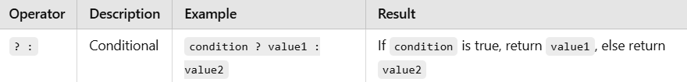

1. **Control Flow Statements in C**

**THEORY EXERCISE**:

Explain decision-making statements in C (if, else, nested if-else, switch).

In C programming, decision-making statements control the flow of program execution based on certain conditions. These statements help the program to choose different paths of execution depending on whether a condition is true or false. The key decision-making statements in C are:

1. **if Statement**
2. **else Statement**
3. **nested if-else Statement**
4. **switch Statement**

#### 1. if **Statement**

The if statement is the simplest form of decision-making. It evaluates a condition, and if the condition is true, the code inside the if block is executed. If the condition is false, the program skips the if block and continues executing the remaining code.

**Syntax:**

if (condition) {

// code to execute if the condition is true

}

**Example:**

#include <stdio.h>

int main( ) {

int a = 10;

if (a > 5) {

printf("a is greater than 5");

}

}

**Explanation:**

* The if statement checks if a > 5. Since the condition is true (because a = 10), the message "a is greater than 5" will be printed.

#### 2. else **Statement**

The else statement is used in conjunction with the if statement. It defines a block of code to execute if the condition in the if statement is false.

**Syntax:**

if (condition) {

// code to execute if the condition is true

} else {

// code to execute if the condition is false

}

**Example:**

#include <stdio.h>

int main() {

int a = 3;

if (a > 5) {

printf("a is greater than 5\n");

} else {

printf("a is less than or equal to 5\n");

}

}

**Explanation:**

* The condition a > 5 is false (because a = 3), so the code inside the else block is executed, printing "a is less than or equal to 5".

#### 3. nested if-else **Statement**

A nested if-else statement is an if-else statement inside another if or else block. This allows more complex decision-making with multiple conditions.

**Syntax:**

if (condition1) {

if (condition2) {

// code to execute if both condition1 and condition2 are true

} else {

// code to execute if condition1 is true, but condition2 is false

}

} else {

// code to execute if condition1 is false

}

**Example:**

#include <stdio.h>

int main() {

int a = 10;

int b = 5;

if (a > 5) {

if (b < 10) {

printf("a is greater than 5 and b is less than 10\n");

} else {

printf("a is greater than 5 and b is not less than 10\n");

}

} else {

printf("a is less than or equal to 5\n");

}

}

**Explanation:**

* The outer if checks if a > 5 (true because a = 10), then the inner if checks if b < 10 (true because b = 5).
* The message "a is greater than 5 and b is less than 10" is printed.

#### 4. switch **Statement**

The switch statement is used to handle multiple possible conditions based on the value of a variable. It is often used when you have several conditions to check against the same variable.

**Syntax:**

switch (expression) {

case value1:

// code to execute if expression == value1

break;

case value2:

// code to execute if expression == value2

break;

default:

// code to execute if expression doesn't match any case

}

**Example:**

#include <stdio.h>

int main() {

int day = 3;

switch (day) {

case 1:

printf("Monday\n");

break;

case 2:

printf("Tuesday\n");

break;

case 3:

printf("Wednesday\n");

break;

case 4:

printf("Thursday\n");

break;

case 5:

printf("Friday\n");

break;

default:

printf("Invalid day\n");

}

}

**Explanation:**

* The switch statement checks the value of day. Since day = 3, it matches the case 3, and the message "Wednesday" is printed.
* The break statement ensures that once a case is matched, the program exits the switch block and doesn't check further cases.

**6. Looping in C**

Compare and contrast while loops, for loops, and do-while loops. Explain the scenarios in which each loop is most appropriate.

In **C programming**, **while loops**, **for loops**, and **do-while loops** are all used to execute code repeatedly. However, they differ in how and when the condition is evaluated and the scenarios in which they are most appropriate. Let's compare and contrast them in terms of their syntax, behaviour, and typical use cases.

**1. While Loop in C**

**Syntax:**

while (condition) {

// Code to execute as long as condition is true

}

* **How it works:** The while loop checks the condition before executing the loop body. If the condition evaluates to false initially, the loop will not execute at all. If the condition evaluates to true, the loop will execute repeatedly until the condition becomes false.
* **Use cases:**
  + When the number of iterations is not known beforehand.
  + When you want to repeatedly check a condition before performing an action.
  + Suitable for scenarios where the loop might not need to run at all (e.g., waiting for user input or waiting for a process to complete).
* **Example:**

int count = 0;

while (count < 5) {

printf("%d\n", count);

count++;

}

In this example, the loop will print numbers from 0 to 4.

* **Advantages:**
  + Flexible, allowing the condition to change dynamically.
  + Can be used for indefinite loops when the termination condition depends on the results of the loop body.
* **Disadvantages:**
  + If the condition is not properly managed, it may lead to an infinite loop.
  + The condition is checked before entering the loop, so if the condition is initially false, the body will never execute.

**2. For Loop in C**

**Syntax:**

for (initialization; condition; update) {

// Code to execute while condition is true

}

* **How it works:** The for loop is typically used when the number of iterations is known beforehand. It consists of three parts:
  1. **Initialization** (executed once at the start).
  2. **Condition** (checked before each iteration).
  3. **Update** (executed after each iteration).
* **Use cases:**
  1. When you know in advance how many times the loop should run (e.g., iterating through an array or performing a task a set number of times).
  2. Ideal for looping over a range of values or iterating through an array.
* **Example:**

for (int i = 0; i < 5; i++) {

printf("%d\n", i);

}

This example will print numbers from 0 to 4. The initialization (i = 0), condition (i < 5), and update (i++) are all part of the loop construct.

* **Advantages:**
  1. Compact and easy to use when the loop needs to run a set number of times.
  2. The initialization, condition, and update steps are contained in a single line, making it easier to read and manage.
* **Disadvantages:**
  1. Less flexible when the number of iterations is not known in advance or when the loop condition depends on external factors.

**3. Do-While Loop in C**

**Syntax:**

do {

// Code to execute

} while (condition);

* **How it works:** The do-while loop guarantees that the loop body will execute at least once, regardless of whether the condition is initially true or false. After the body is executed, the condition is checked, and if it evaluates to true, the loop will execute again.
* **Use cases:**
  + When you need the loop to execute at least once, even if the condition is false at the start.
  + Ideal for scenarios where an action must be taken before the condition is checked (e.g., prompting the user for input and validating it afterward).
* **Example:**

int number;

do {

printf("Enter a number (0 to stop): ");

scanf("%d", &number);

} while (number != 0);

In this case, the user is prompted to enter a number at least once, and the loop continues until the user enters 0.

* **Advantages:**
  + Ensures that the loop body is executed at least once, which is useful in cases where you want to ensure an action occurs before checking the condition.
* **Disadvantages:**
  + The condition is checked after the loop body, which can lead to unnecessary executions if the condition is initially false.
  + Less commonly used than for or while loops.

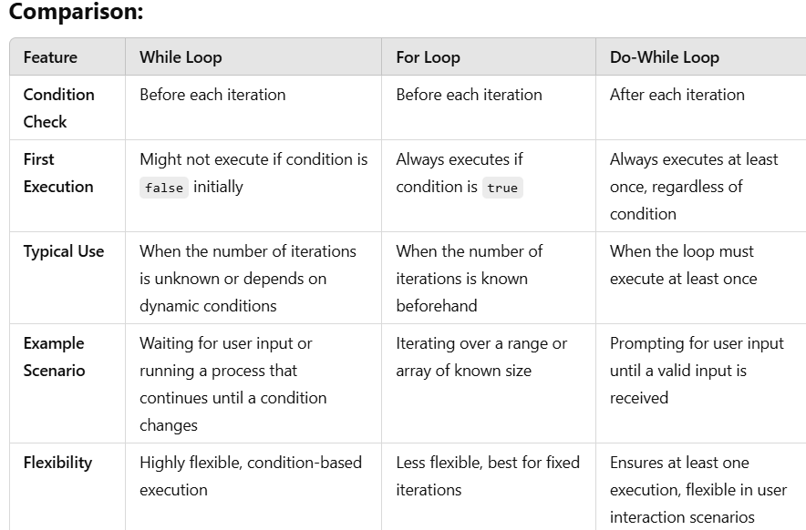

**7. Loop Control Statements**

**THEORY EXERCISE**:

Explain the use of break, continue, and go to statements in C. Provide examples of each.

In C, the break, continue, and goto statements are used to alter the flow of control in loops and conditionals. They are powerful control statements that can be used to exit loops, skip certain parts of code, or jump to specific sections within a program.

### 1. break ****Statement:****

The break statement is used to immediately exit from a loop or a switch statement. Once break is encountered, the control moves to the statement following the loop or switch.

#### **Use Case:**

* Exiting a loop when a certain condition is met.
* Exiting from a switch statement early.

### 2. continue ****Statement:****

The continue statement skips the rest of the code in the current iteration of the loop and proceeds to the next iteration. The loop condition is re-evaluated, and if the condition still holds, the loop continues.

#### **Use Case:**

* Skipping a particular iteration in a loop based on a condition.
* When you want to bypass the rest of the loop for a specific iteration.

### 3. goto ****Statement:****

The goto statement is used to jump to a specific label within the function. It allows jumping to any part of the program that is labelled. This can make the flow of control less structured, and its use is often discouraged because it can make the code harder to read and maintain.

**8. Functions in C**

**THEORY EXERCISE**

What are functions in C? Explain function declaration, definition, and how to call a function. Provide examples.

#### **Use Case:**

* Jumping to a specific part of the code.
* Exiting deeply nested loops or conditionals (though there are usually better alternatives, like break or return).

In C, a **function** is a block of code that performs a specific task. Functions help organize and modularize the program by allowing code to be reused. They provide a way to break down large problems into smaller, manageable pieces.

### Key Concepts of Functions in C:

1. **Function Declaration (or Function Prototype):** This tells the compiler about the function's name, return type, and parameters (if any). It is often placed before the main() function or at the top of the program.
2. **Function Definition:** This provides the actual implementation of the function, where the function's body is written, and the logic is implemented.
3. **Function Call:** This is where the function is invoked in the program to perform its task.

### Components of a Function:

1. **Return Type:** The type of value the function will return (e.g., int, float, char). If the function does not return anything, the return type is void.
2. **Function Name:** The name used to identify the function.
3. **Parameters (Optional):** The variables passed to the function. These are used as inputs to the function.
4. **Function Body:** The block of code that executes when the function is called.

### 1. ****Function Declaration (Prototype):****

The function declaration provides information to the compiler about the function's return type, name, and parameters (if any), but does not contain the actual code. It is usually placed before the main() function or wherever the function is used.

#### Syntax:

return type function name(parameter1_type parameter1_name, parameter2_type parameter2_name, ...);

#### Example:

int add(int, int); // Function declaration (prototype)

### 2. ****Function Definition:****

The function definition contains the actual code that is executed when the function is called. This includes the return type, function name, parameters, and the code inside the function body.

#### Syntax:

return type function name(parameter1_type parameter1_name, parameter2_type parameter2_name, ...) {

// function body

// perform task and return result (if necessary)

}

#### Example:

int add(int a, int b) { // Function definition

return a + b;

}

### 3. ****Function Call:****

A function call is where the function is actually invoked in the program to perform the task. When calling the function, you provide the arguments (values or variables) that match the parameters of the function.

#### Syntax:

function name(argument1, argument2, ...);

#### Example:

int result = add(3, 5); // Function call

**9. Arrays in C**

**THEORY EXERCISE**:

Explain the concept of arrays in C. Differentiate between one-dimensional and multi-dimensional arrays with examples.

Array is a collection of elements with similar data types.

e. g s1, s2, s3,s4, s5, s6, s7 = integer

e. g sub[7] : 0 to 6

Array elements can be identified by index number.

Index number will be started from "0" always.

Syntax : datatype array name[size];

e. g : int sub[5]; 0 to 4

-Types of Arrays :

--------------------------------

1. One Dimensional Array e. g int arr[5];

2. Two Dimensional Array e. g int arr[3][2];

3. Multi Dimensional Array e. g int arr[2][3][3];

1. One Dimensional Array e. g int arr[5];

Syntax : datatype arrayname[size];

e. g : int sub[5]; 0 to 4

2. Two Dimensional Array e. g int arr[3][2];

syntax : datatype array size [rowsize][colsize];

e. g int arr[2][2];

int arr[2][2] = 4 elements

int arr[2][3] = 6 elements

int arr[3][2] = 6 elements

int arr[3][3] = 9 elements

3. Multi Dimensional Array e. g int arr[3][2][2];

int mat [3] [2] [2];

no. of arrays row size col size

**10. Pointers in C**

**THEORY EXERCISE**:

Explain what pointers are in C and how they are declared and initialized. Why are pointers important in C?

A **pointer** in C is a variable that stores the memory address of another variable.

### Declaring and Initializing Pointers

To declare a pointer, you specify the type of data the pointer will point to, followed by an asterisk (*) before the pointer name. Here's how you can declare and initialize pointers:

#### 1. Declaring Pointers

* Syntax:

type *pointer name;

Example:

int *ptr; // Declares a pointer to an integer

char *str; // Declares a pointer to a character

#### 2. Initializing Pointers

Pointers can be initialized in several ways:

* **Assigning the address of a variable**:  
  You can use the address-of operator (&) to assign the address of a variable to the pointer.

Example:

int var = 10;

int *ptr = &var; // ptr now points to the memory location of var

* **Assigning NULL to a pointer**:  
  It's a good practice to initialize a pointer to NULL if it's not assigned an address immediately. This avoids "dangling" or uninitialized pointers that could point to random memory.

Example:

int *ptr = NULL; // Pointer is not pointing to any valid memory yet

* **Using dynamic memory allocation**:  
  You can assign memory to a pointer dynamically using functions like malloc or calloc.

Example:

int *ptr = (int*) malloc(size of(int)); // Allocates memory for an integer

### Why are Pointers Important?

1. **Efficient memory usage**: Pointers allow you to work with large data structures (such as arrays, linked lists, and trees) efficiently, without copying the entire structure every time.
2. **Dynamic memory allocation**: With pointers, you can allocate memory dynamically using functions like malloc, calloc, or realloc.
3. **Function arguments**: By passing pointers to functions, you can modify the actual data, not just a copy, allowing for more flexible function calls.
4. **Array manipulation**: Pointers and arrays are closely linked. In C, arrays are essentially pointers to their first element, and pointers can be used to navigate through arrays efficiently.
5. **Low-level memory access**: Pointers enable direct memory manipulation, which can be crucial in systems programming, operating systems, or when interfacing with hardware.

**11. Strings in C**

**THEORY EXERCISE**:

Explain string handling functions like strlen(), strcpy(), strcat(), strcmp(), and strchr(). Provide examples of when these functions are useful.

in C programming, string handling functions are used to manipulate and work with strings (arrays of characters). These functions are defined in the header file <string.h>. Below are explanations of common string handling functions in C, including strlen(), strcpy(), strcat(), strcmp(), and strchr().

### 1. strlen(): Length of a String

* **Function**: strlen() is used to get the length of a string (excluding the null terminator \0).
* **Syntax**:

size_t strlen(const char *str);

* **Example**:

#include <stdio.h>

#include <string.h>

int main() {

char str[] = "Hello";

printf("Length of the string: %lu\n", strlen(str)); // Output: 5

return 0;

}

* **When Useful**:
  + To know the size of a string.
  + To perform operations like looping through a string or dynamically allocating memory.

### 2. strcpy(): Copy a String

* **Function**: strcpy() is used to copy the contents of one string into another.
* **Syntax**:

char *strcpy(char *dest, const char *src);

* **Example**:

#include <stdio.h>

#include <string.h>

int main() {

char src[] = "Hello, world!";

char dest[50];

strcpy(dest, src);

printf("Copied string: %s\n", dest); // Output: Hello, world!

return 0;

}

* **When Useful**:
  + To create a copy of a string.
  + Useful when you need to preserve the original string or manipulate a copy.

### 3. strcat(): Concatenate Two Strings

* **Function**: strcat() is used to concatenate (append) one string to the end of another string.
* **Syntax**:

char *strcat(char *dest, const char *src);

* **Example**:

#include <stdio.h>

#include <string.h>

int main() {

char str1[50] = "Hello";

char str2[] = " World!";

strcat(str1, str2); // str1 is now "Hello World!"

printf("Concatenated string: %s\n", str1);

return 0;

}

* **When Useful**:
  + To combine two strings into one.
  + Useful when building a sentence, or appending strings together (e.g., file paths).

### 4. strcmp(): Compare Two Strings

* **Function**: strcmp() is used to compare two strings lexicographically.
* **Syntax**:

int strcmp(const char *str1, const char *str2);

* **Example**:

#include <stdio.h>

#include <string.h>

int main() {

char str1[] = "apple";

char str2[] = "banana";

int result = strcmp(str1, str2);

if (result == 0)

printf("Strings are equal.\n");

else if (result < 0)

printf("str1 is smaller than str2.\n");

else

printf("str1 is greater than str2.\n");

return 0;

}

* **When Useful**:
  + To compare two strings and determine if they are equal, or to find which is lexicographically larger.
  + Useful in sorting strings or comparing user input.

### 5. strchr(): Locate a Character in a String

* **Function**: strchr() is used to find the first occurrence of a character in a string.
* **Syntax**:

char *strchr(const char *str, int c);

* **Example**:

#include <stdio.h>

#include <string.h>

int main() {

char str[] = "Hello, world!";

char *result = strchr(str, 'o');

if (result != NULL)

printf("Found 'o' at position: %ld\n", result - str); // Output: 4

else

printf("Character not found.\n");

return 0;

}

* **When Useful**:To find the first occurrence of a specific character in a string.

Useful when parsing or searching strings, like looking for a specific delimiter or character.

**12. Structures in C**

**THEORY EXERCISE**:

Explain the concept of structures in C. Describe how to declare, initialize, and access structure members.

A **structure** in C is a user-defined data type that groups variables of different types under a single name. It allows you to organize related data together.

**Declaring a Structure**

To declare a structure, you use the struct keyword, followed by the structure name and its members.

struct Student {

char name[50];

int age;

float grade;

};

**Initializing a Structure**

You can initialize a structure when you declare it, like this:

struct Student s1 = {"John", 20, 85.5};

Or, you can initialize it after declaration:

struct Student s1;

s1.age = 20;

strcpy(s1.name, "John");

s1.grade = 85.5;

**Accessing Structure Members**

To access the members of a structure, you use the **dot operator (.)**.

printf("%s\n", s1.name); // Accessing name

printf("%d\n", s1.age); // Accessing age

printf("%.2f\n", s1.grade); // Accessing grade

If you're using a pointer to the structure, you use the **arrow operator (->)**.

struct Student *ptr = &s1;

printf("%s\n", ptr->name); // Accessing name using pointer

* **Declare**: struct Type { member1; member2; } variable;
* **Initialize**: At declaration or later with the dot operator.
* **Access**: Use the dot operator for structure variables, and arrow operator for pointers.

**13. File Handling in C**

**THEORY EXERCISE**:

Explain the importance of file handling in C. Discuss how to perform file operations like opening, closing, reading, and writing files.

File handling in C allows programs to store data permanently outside the program, even after it has finished running. This is crucial for:

* **Data Persistence**: Data saved to a file can be accessed later, unlike data in memory that is lost when the program ends.
* **Data Sharing**: Files allow sharing data between different programs or users.
* **Handling Large Data**: Large datasets can be stored in files, reducing memory usage.
* **Configuration and Logging**: Files are commonly used for storing configuration settings and logging application events.

### File Operations in C

In C, file operations are performed using functions from the stdio.h library. The basic file operations are **opening**, **reading**, **writing**, and **closing** files.

#### 1. **Opening a File**

You use fopen() to open a file for reading or writing. It takes two parameters: the filename and the mode.

**Syntax**:

FILE *fopen(const char *filename, const char *mode);

**Example**:

FILE *file = fopen("data.txt", "r"); // Open file for reading

#### 2. **Reading from a File**

You can read from a file using fgetc(), fgets(), or fread(), depending on your need.

**Example**:

char ch;

FILE *file = fopen("data.txt", "r");

while ((ch = fgetc(file)) != EOF) {

putchar(ch); // Display content on screen

}

fclose(file);

#### 3. **Writing to a File**

You can write to a file using fputc(), fputs(), or fprintf().

**Example**:

FILE *file = fopen("data.txt", "w");

fprintf(file, "Hello, World!\n");

fclose(file);

#### 4. **Closing a File**

After completing file operations, close the file using fclose() to ensure all data is saved and resources are freed.

**Syntax**:

int fclose(FILE *file);

**Example**: fclose(file);